Nama : Viona Paramitha

Kelas : 5C

NIM : 18090097

Praktikum 5

1. Source Code : MatakuliahValidation.php >>> application/controllers/

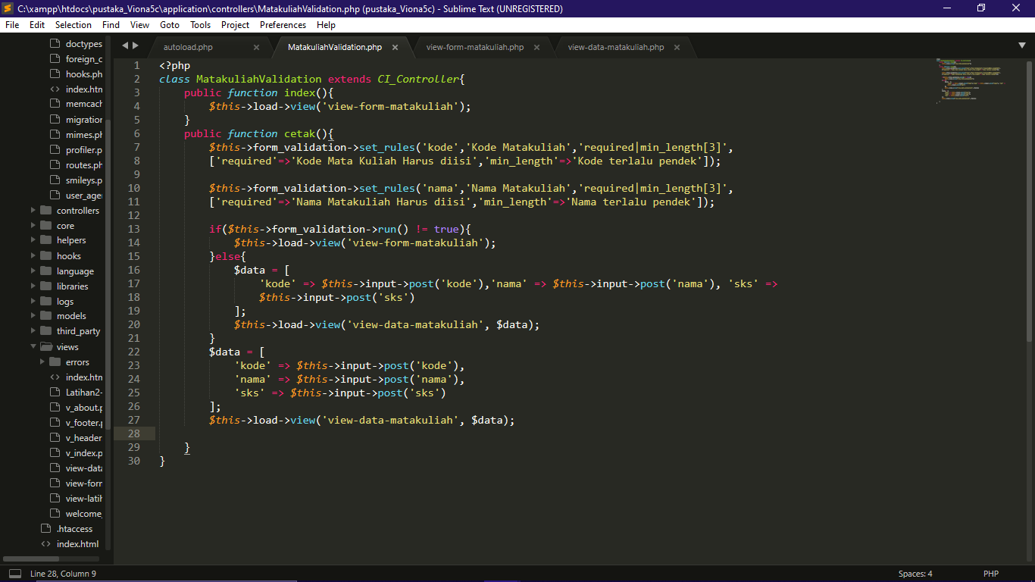

1. Source Code : autoload.php >>> application/config/

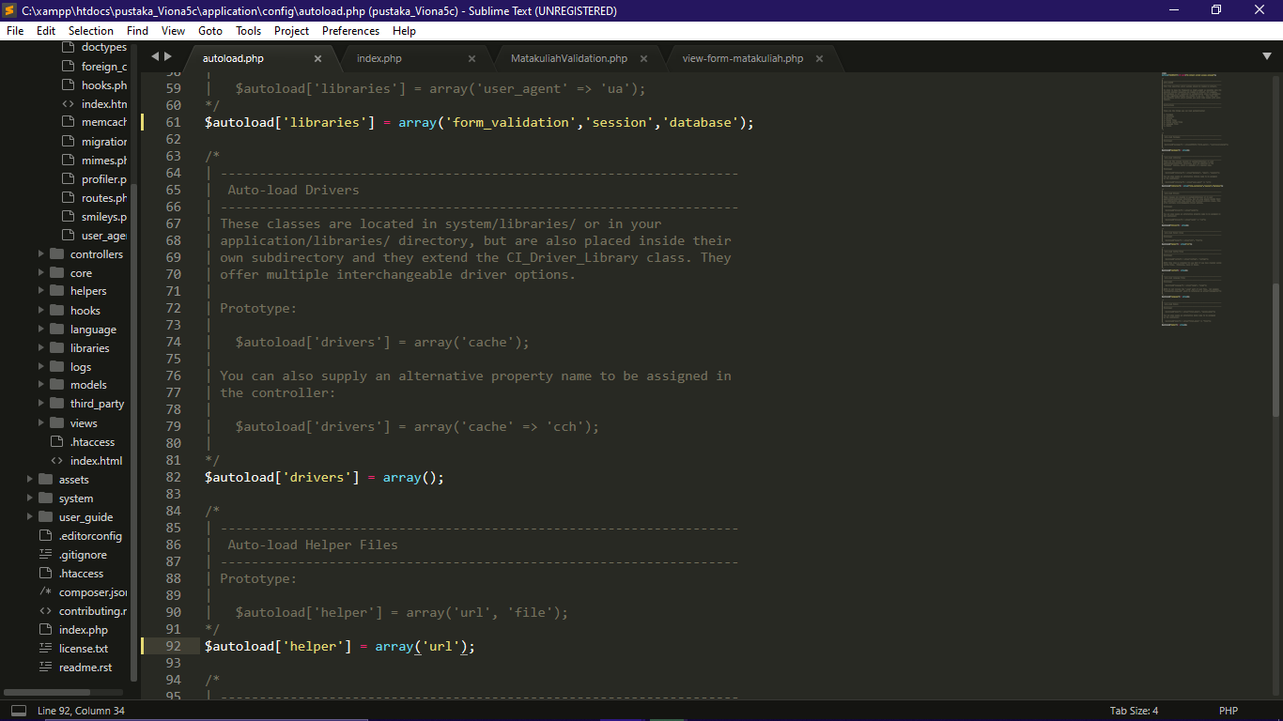

1. Source Code : view-form-matakuliah.php >>> application/views/

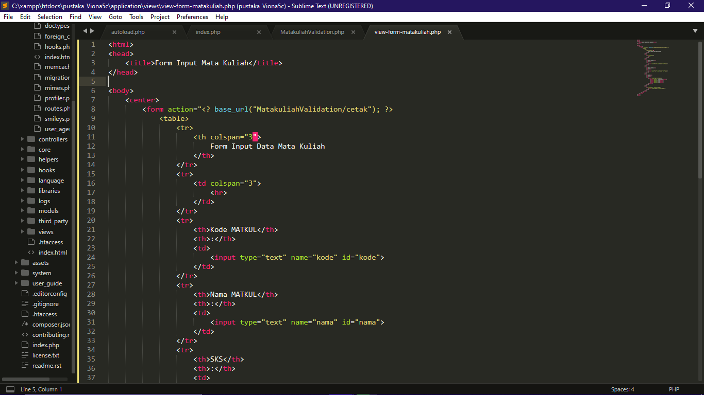

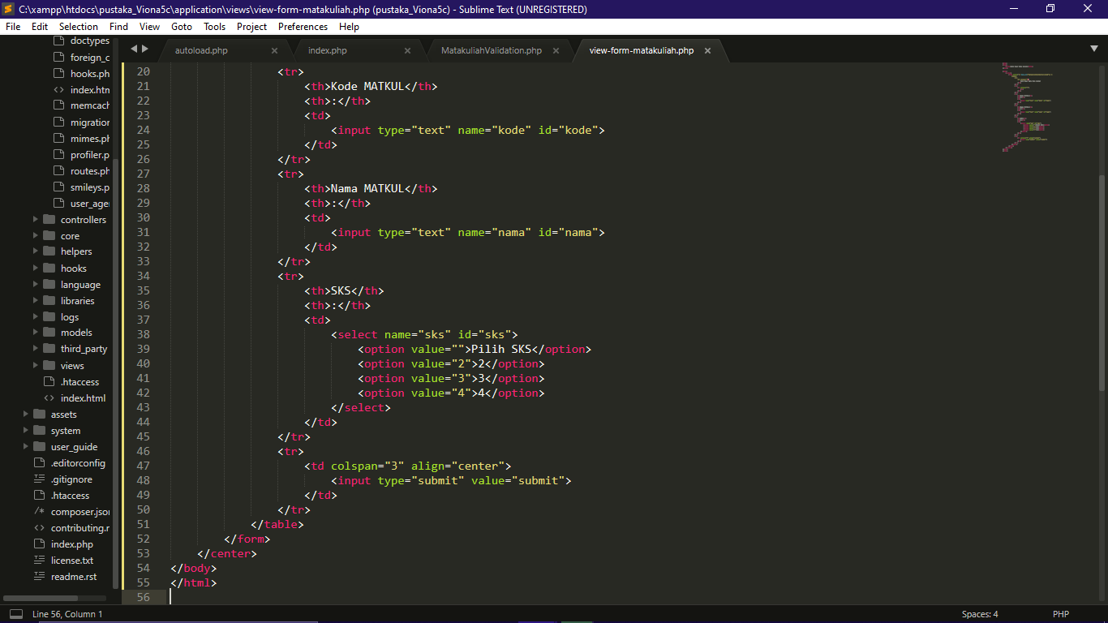

Hasil URL : <http://localhost/pustaka_Viona5c/index.php/MatakuliahValidation>

Capture Hasil :

